**A picture containing clipart

Description generated with very high confidence**

SELENIUM TEST CASE IN ECLIPSE

DevOps Certification Training

[**support@intellipaat.com**](mailto:support@intellipaat.com)

**+91-7022374614**

**US: 1-800-216-8930(Toll Free)**

**SELENIUM TEST CASE IN ECLIPSE**

**This documentation is divided into three parts:**

1. **Java JDK installation**
2. **Eclipse installation**
3. **Selenium Test Case**

**Install Java JDK**

**Step 1:** Download java jdk.

https://www.oracle.com/technetwork/java/javase/downloads/index.html

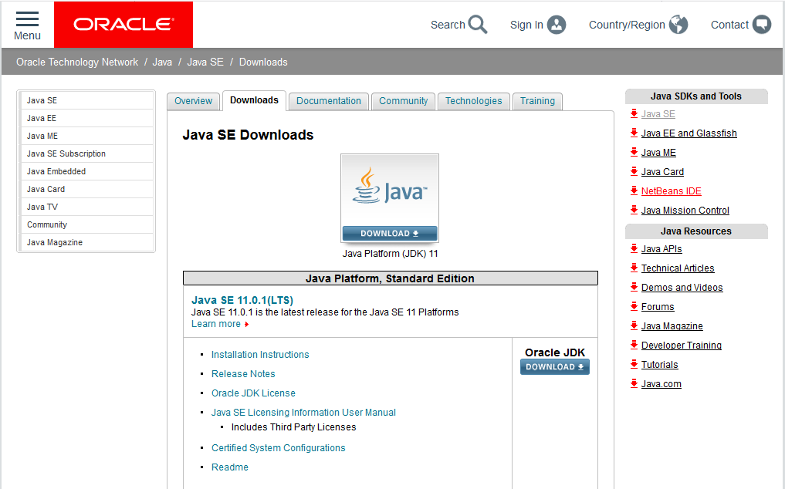

Then Click on the oracle Jdk Download button, you will land on a page as shown below. Accept the License Agreement. Download the .exe file.

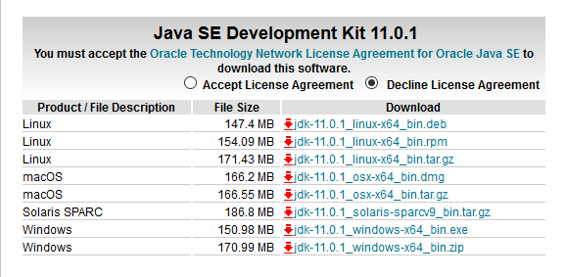

**Step 2:** Open that downloaded execution file then click on **Next**.

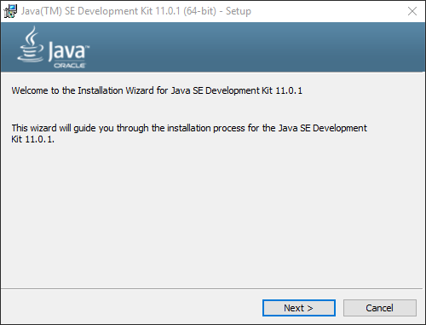

**Step 3:** Select **Developers Tools** and click **Next**.

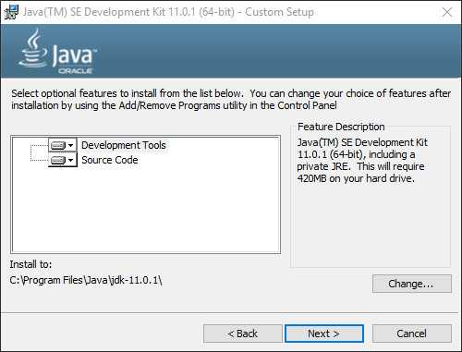

**Step 4:** It will take a few moments to set up jdk in your system

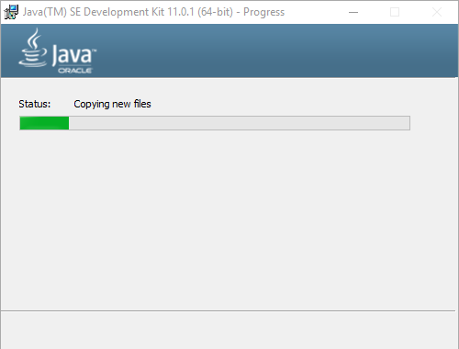

**Step 5:** Click on close to complete the set up.

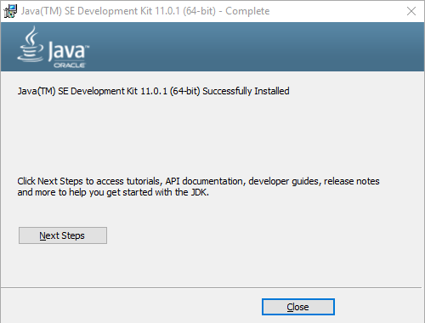

Before moving ahead, we need **to add the environment variables to the path** as follows.

**Step 5:** Go to local **C drive** 🡪 Program Files 🡪java 🡪 **jdk-11.0.1**🡪**bin**

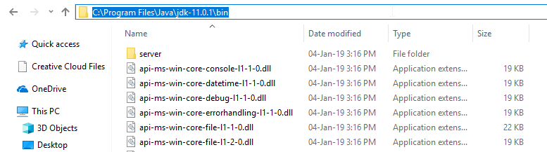

**Step 6:** Copy the path as shown above.

**Step 7:** Go to **Control Panel** 🡪 **System and Security** 🡪**System**🡪 **Advanced System Settings**

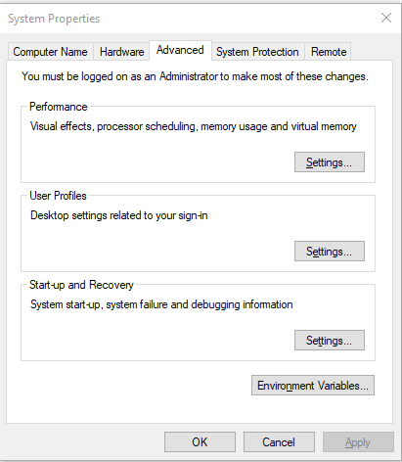

**Step 8:** Click on **Environment Variables.**

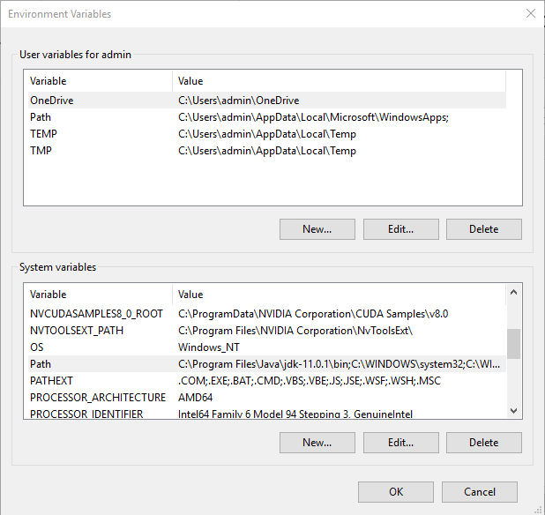

**Step 9:** Click on Path in the System Variables section. And then paste the previously copied path (***C:\Program Files\Java\jdk-11.0.1\bin***) as shown below.

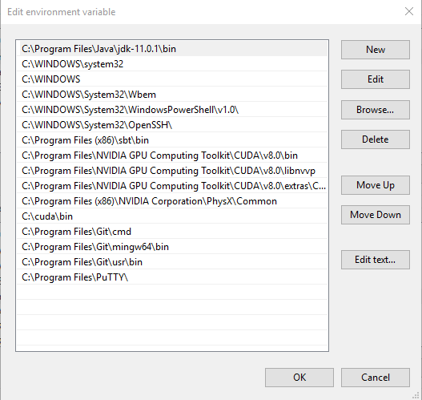

**Step 10:** Now open **command prompt** and run the following command.

java -version

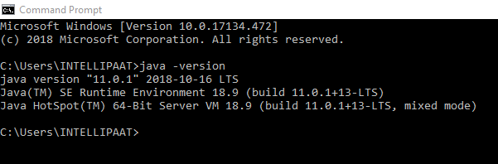

**2. Eclipse Installation**

**Step 1:** Go to the eclipse download page.

https://www.eclipse.org/downloads/

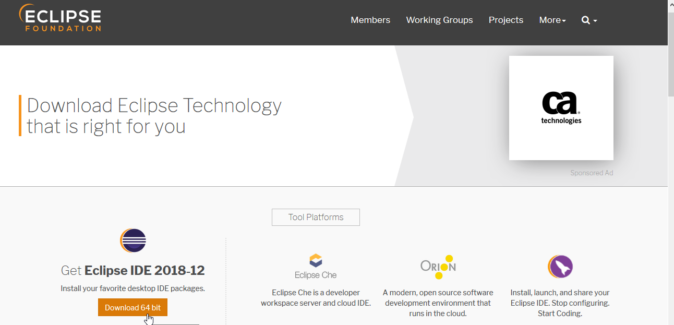

**Step 2:** Click on the download 64-bit link. You should land on a page as shown.

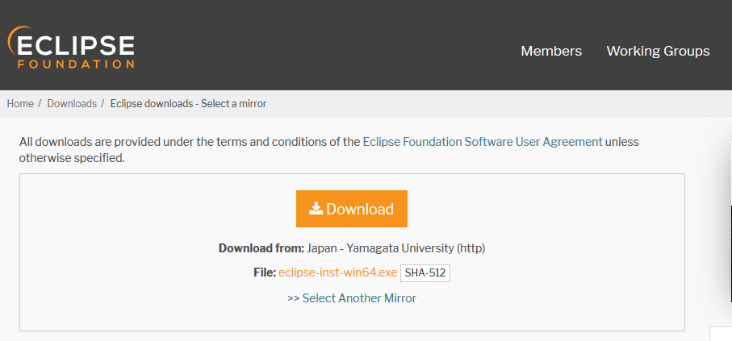

**Step 3:** Once the download is finished launch the installer.

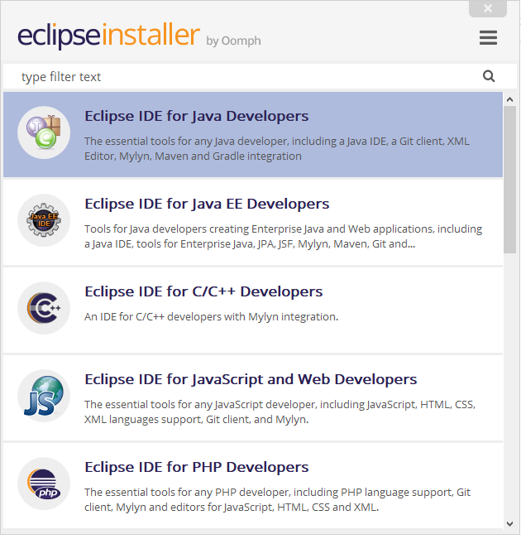

**Step 4:** Click on **Eclipse IDE for Java Developers.**

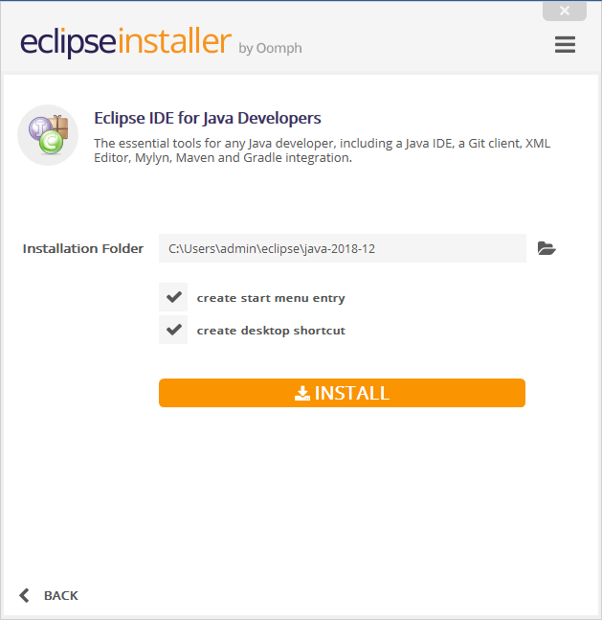

**Step 5:** Once done, click on LAUNCH.

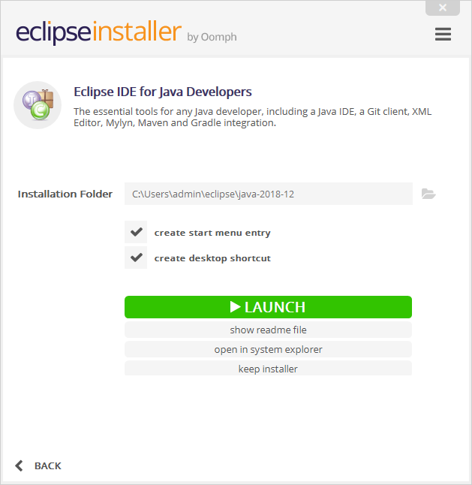

**Step 6:** Click on Launch.

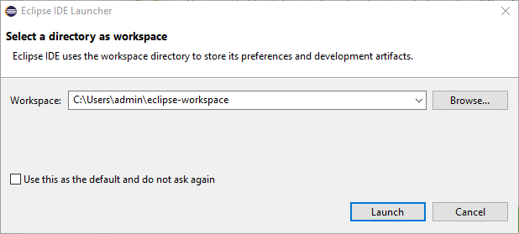

**Now that we have successfully set up Java and Eclipse in our environment, we will be Performing a Selenium Test Case using Maven.**

**3. Selenium Test Case:**

**Step 1:** Start a new Maven Project.

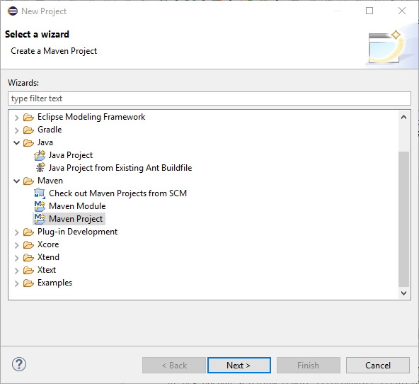

**Step 2:** Check the **Create a Simple Project** box. And click **Next.**

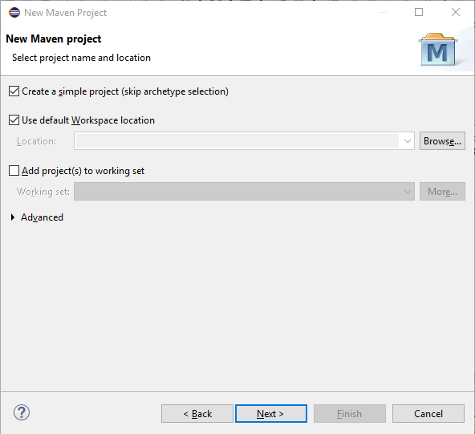

**Step 3:** Enter **Group Id** and **Artifact Id.** And click on **Finish.**

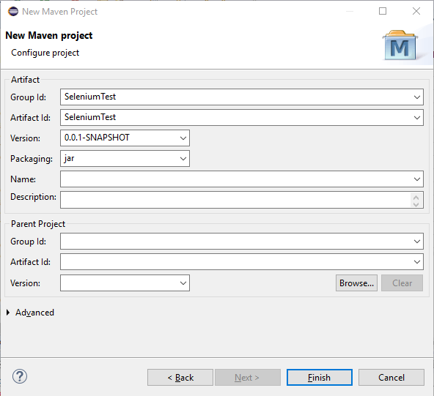

**Step 4:** Your project should appear in the **Project Explorer** section as shown below.

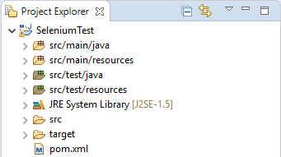

**Step 5:** Right click on **src/main/java** and create a **java package.** Enter a **Package Name (Test** in this case**).** Then click on **Finish.**

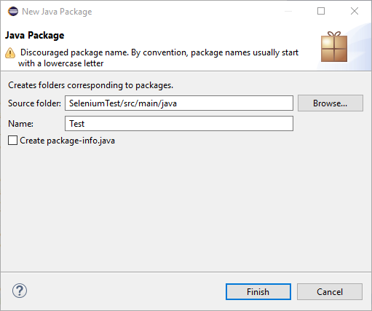

**Step 6:** Now create a **Java Class** by right clicking on **test package**, name the class as **App.** Check the **Public static void main(String[] args)** box**.** And click on **Finish.**

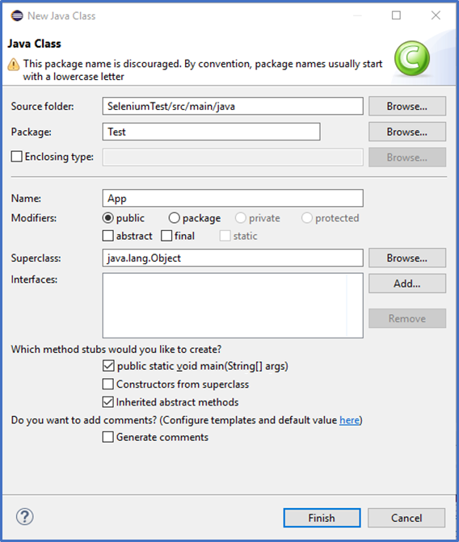

**Step 7:** Now, your eclipse workspace should look like this.

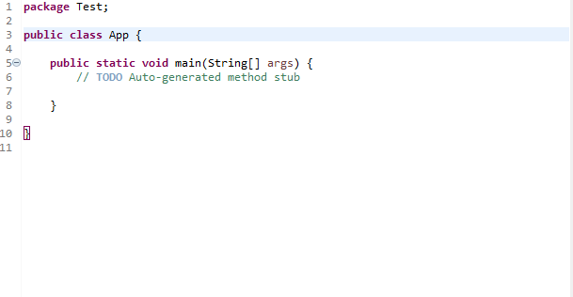

Before moving on to the scripting part we need to **configure the Maven Dependencies to perform Selenium in Eclipse**. We will be adding the **Maven Dependencies** to the **Pom.xml** file under **target folder**.

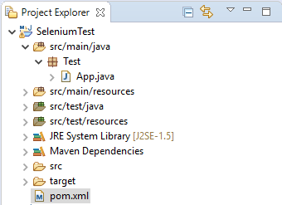

Before adding the dependencies, the Pom.xml file looks like this:

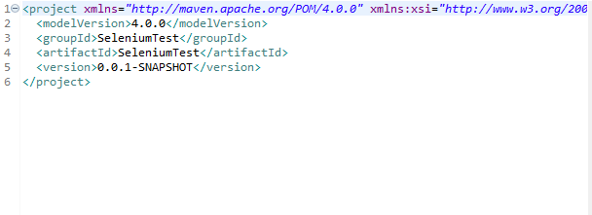

**Step 8:** Now go ahead and add the below dependencies to the **pom.xml** file.

<dependencies>

<!-- Selenium -->

<dependency>

<groupId>org.seleniumhq.selenium</groupId>

<artifactId>selenium-java</artifactId>

<version>3.4.0</version>

</dependency>

<!-- TestNG -->

<dependency>

<groupId>org.testng</groupId>

<artifactId>testng</artifactId>

<version>6.8</version>

<scope>test</scope>

</dependency>

<!-- Selenium Server-->

<dependency>

<groupId>org.seleniumhq.selenium</groupId>

<artifactId>selenium-server</artifactId>

<version>3.141.59</version>

</dependency>

</dependencies>

Add the dependencies in between **<project> </project>** tags.

Refer to the below given image.

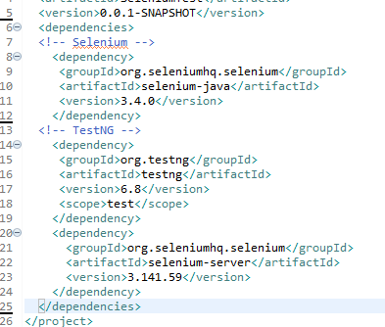

**Step 9:** Now, add the below given script to the **main() function** to the **App.java** file.

System.setProperty("webdriver.chrome.driver", "D:\\Selenium\\driver\\chromedriver.exe");

WebDriver driver = new ChromeDriver();

driver.get("http://www.gmail.com/");

System.out.println("Test Successful");

**Step 10:** To make this run properly we need to import **org.openqa.selenium.WebDriver** and **org.openqa.selenium.chrome.ChromeDriver**

import org.openqa.selenium.WebDriver;

import org.openqa.selenium.chrome.ChromeDriver;

It should look like this.

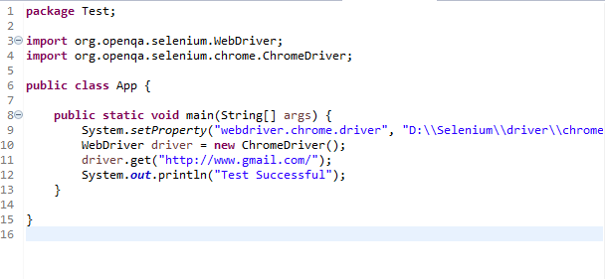

**Step 11:** Now run **App**. Chrome browser window will pop up with Gmail sign in page.

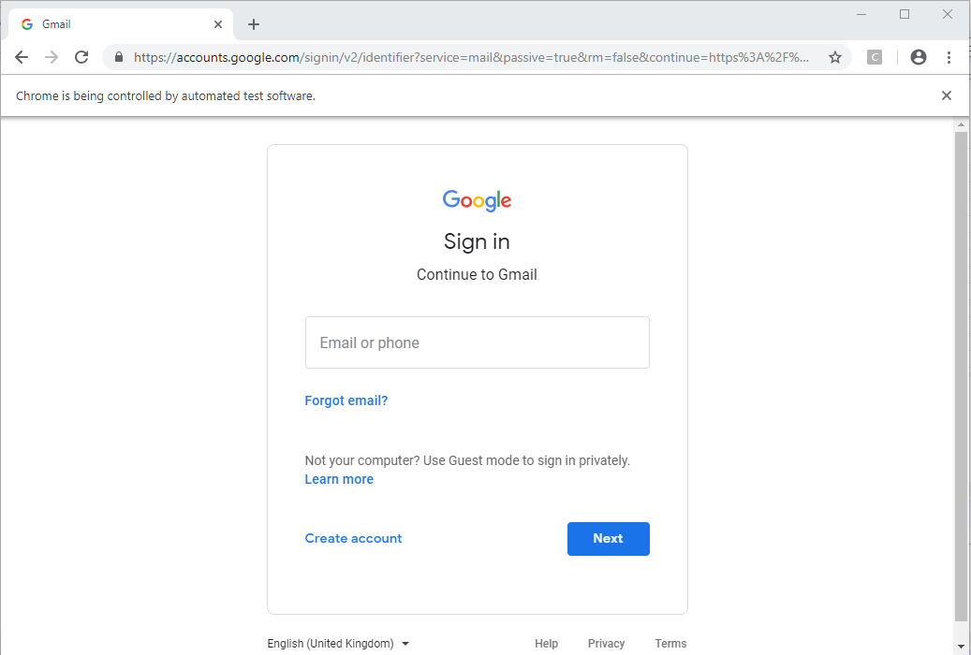

**Step 12:** Go to Eclipse again and see the console. You should see the Test Successful message appearing in there.

